

Mini Project Report – 07

Master of Computer Application – General Semester – I

Sub: Frontend Frameworks and Technologies Topic: Resume Website with CSS Styling

By
Name: Ashraj Singh Rana
Reg no.: PROV/ASAC/MCA/7/26/058

Faculty Name: VEERA RAGHAV K

Faculty Signature:

Department of Computer Application Alliance University
Chandapura - Anekal Main Road, Anekal Bengaluru - 562 106
August 2026

INDEX

Fig No. | Name | Page No.
1. | Introduction | 1
2. | Input code | 2 – 9
3. | Output code | 10
4. | Conclusion | 11

INTRODUCTION
A resume website is a responsive web-based project developed using HTML and CSS to present a individual’s professional profile, educational background, technical skills, work experience, achievements and contact information in a clear and organized manner. The website follows a clean and professional layout withs sections such as profile, career objectives, education, skills, experience, project, certifications and contact details. HTML is used to structure and arrange the resume content, while CSS is used to design the visual appearances, including colours, typography, spacing, section, layouts, buttons, and responsive elements. CSS is used to design the visual appearance, including colours, typography, spacing, section, layouts, buttons, and responsive elements. CSS is used to design the visual appearance, including colour.

INPUT CODE
<!DOCTYPE html>
<html lang="en">

<head>
<meta charset="UTF-8">
<meta name="viewport" content="width=device-width, initial-scale=1.0">

<title>Ashraj Singh Rana - Resume</title>

<style>
* {
margin: 0;
padding: 0;
box-sizing: border-box;
}

body {
font-family: Arial, sans-serif;
background-color: #e8ecf1;
color: #333;
line-height: 1.6;
}

.resume {
width: 850px;
max-width: 95%;
margin: 30px auto;
background-color: white;
box-shadow: 0 5px 20px rgba(0, 0, 0, 0.15);
}

header {
background-color: #172b4d;
color: white;
text-align: center;
padding: 40px 20px;
}

header h1 {
font-size: 40px;
margin-bottom: 8px;
}

header p {
font-size: 18px;
}

.contact {
margin-top: 20px;
display: flex;
justify-content: center;
gap: 25px;
flex-wrap: wrap;
font-size: 14px;
}

section {
padding: 25px 40px;
border-bottom: 1px solid #ddd;
}

section h2 {
color: #172b4d;
font-size: 24px;
margin-bottom: 15px;
border-bottom: 3px solid #172b4d;
padding-bottom: 5px;
}

.item {
margin-bottom: 18px;
}

.item h3 {
color: #333;
margin-bottom: 5px;
}

.item p {
color: #666;
margin-bottom: 5px;
}

.skills {
display: flex;
flex-wrap: wrap;
gap: 10px;
}

.skills span {
background-color: #172b4d;
color: white;
padding: 8px 15px;
border-radius: 20px;
font-size: 14px;
}

.skills span:hover {
background-color: #304f7d;
cursor: pointer;
transition: 0.3s;
}

.project-title {
font-size: 18px;
color: #222;
margin-bottom: 5px;
}

.technology {
font-size: 13px;
color: #777;
margin-bottom: 8px;
}

.project-description {
margin-left: 20px;
color: #555;
}

.project-description li {
margin-bottom: 6px;
}

button {
height: 40px;
width: 130px;
background-color: #172b4d;
color: white;
border: none;
border-radius: 4px;
cursor: pointer;
font-size: 14px;
}

button:hover {
background-color: #304f7d;
}

.print-area {
text-align: center;
padding: 20px;
margin-bottom: 20px;
}
</style>

</head>

<body>

<div class="resume">

<header>

<h1>Ashraj Singh Rana</h1>

<p>
MCA Student | Full-Stack Developer
</p>

<div class="contact">

<span>
Email: ashrajsingh9@gmail.com
</span>

<span>
Phone: +91 9827900755
</span>

<span>
India
</span>

</div>

</header>

<section>

<h2>Career Objective</h2>

<p>
I am an MCA student who enjoys building simple and useful
websites. I am looking for an opportunity to improve my
development skills and work on real-world projects.
</p>

</section>

<section>

<h2>Education</h2>

<div class="item">

<h3>
Master of Computer Applications (MCA)
</h3>

<p>
Alliance University | Expected graduation: 2026
</p>

</div>

</section>

<section>

<h2>Technical Skills</h2>

<div class="skills">

<span>HTML</span>

<span>CSS</span>

<span>JavaScript</span>

<span>React</span>

<span>Node.js</span>

<span>Express</span>

<span>MongoDB</span>

<span>Git</span>

</div>

</section>

<section>

<h2>Projects</h2>

<div class="item">

<h3 class="project-title">
BALANCEO — Finance Management Web App
</h3>

<p class="technology">
React · Node.js · Express · MongoDB · TypeScript · JWT · Recoil · Render
</p>

<ul class="project-description">

<li>
Migrated full codebase from JavaScript to TypeScript,
fixed broken production build pipeline, and deployed
on Render with UptimeRobot health checks.
</li>

<li>
Implemented JWT authentication, bcrypt password hashing,
protected routes, Recoil state management, and
income/expense analytics dashboard.
</li>

</ul>

</div>

<div class="item">

<h3 class="project-title">
CATCHUP — Real-Time Chat Application
</h3>

<p class="technology">
MongoDB · Express · React · Node.js · WebSocket
</p>

<ul class="project-description">

<li>
Built real-time messaging using WebSocket connections
with privacy-first architecture — users communicate
via unique private IDs, no personal data exposed.
</li>

</ul>

</div>

<div class="item">

<h3 class="project-title">
BOOKVAULT — Library Management System
</h3>

<p class="technology">
Python · Django · Django ORM · SQLite · HTML · CSS
</p>

<ul class="project-description">

<li>
Full-stack library system with role-based dashboards
for librarians and students — book issuance, returns,
fine tracking, and availability counts using Django ORM.
</li>

</ul>

</div>

</section>

<section>

<h2>Certifications</h2>

<div class="item">

<p>
Full Stack Development Cohort (MERN)
</p>

<p>
NPTEL — Programming with Generative AI
</p>

</div>

</section>

<section>

<h2>Strengths</h2>

<div class="item">

<p>
• Willingness to learn new technologies
</p>

<p>
• Problem-solving and attention to detail
</p>

<p>
• Teamwork and communication
</p>

</div>

</section>

<div class="print-area">

<button onclick="window.print()">
Print Resume
</button>

</div>

</div>

</body>

</html>

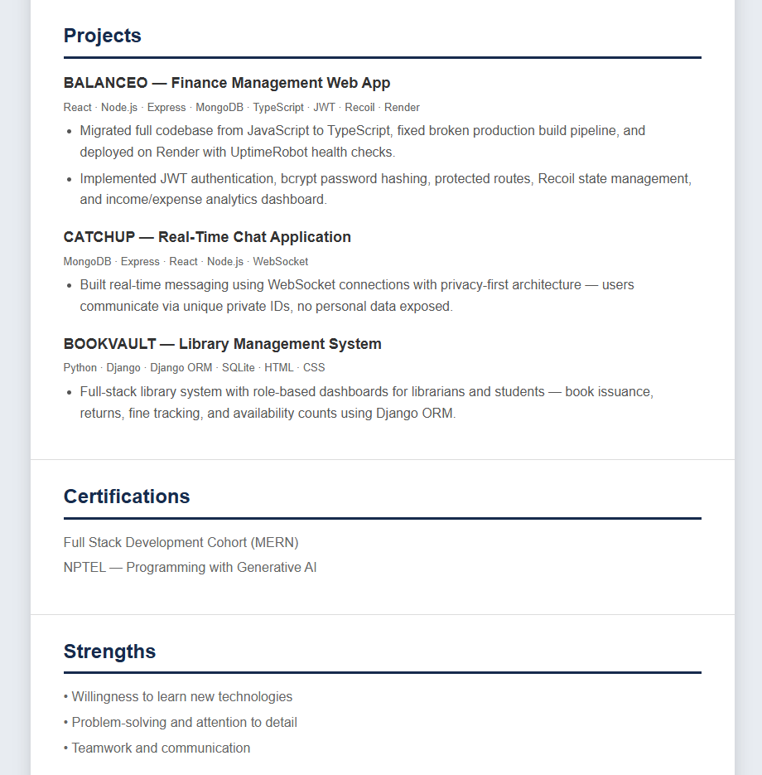
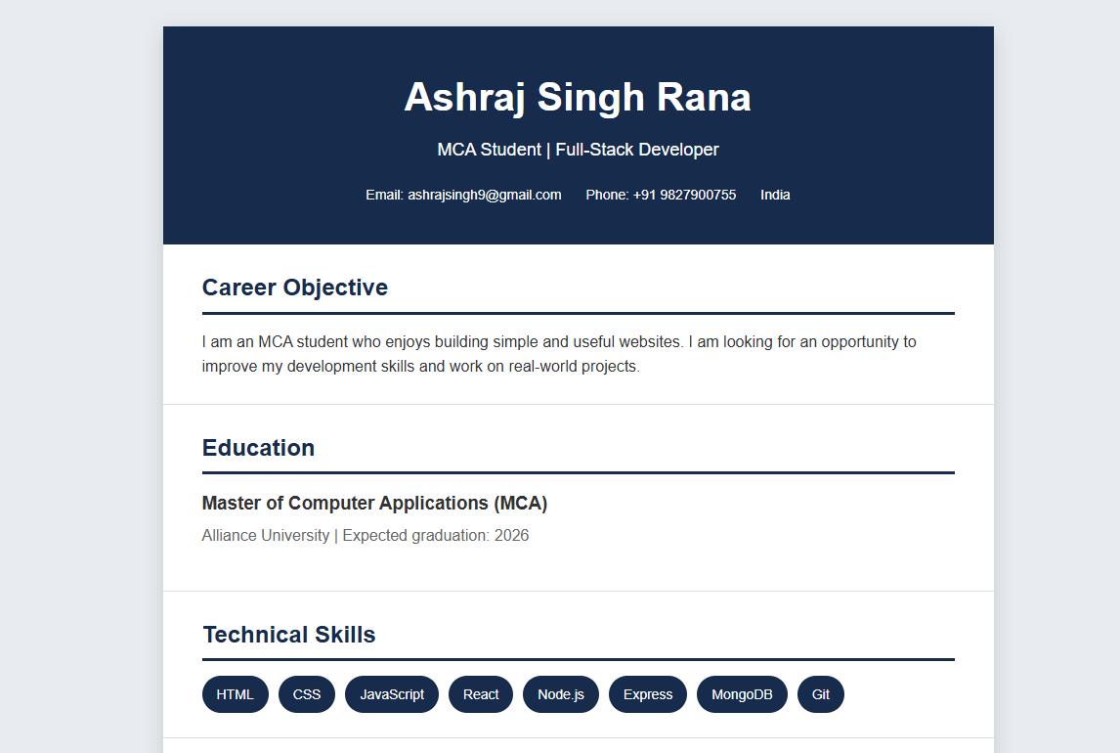
OUTPUT

CONCLUSION
Resume website successfully demonstrates the use of HTML and CSS to create a structured, responsive and professional digital resume. The project presents personal information, career objective educational qualifications, technical skills, work experience, projects, certifications, and contact details in a clear and organized format. CSS styling, flexible layouts, color schemes, typography, section cards, hover effects, and responsive media quires improve the visual appearance and usability of the website. Through this project, essential front end development concepts such as webpage structure, styling, responsive, design, layout management and user-friendly navigation were practically implemented. Overall, the project provides an effective online platform for presenting an individual’s professional profile.

